KENDRIYA VIDYALAYA

**SUMMATIVE ASSESSMENT-**

**Class: III” ” Sub: EVS Date: / /**

**Name: _______________________________Roll No. __________**

|  |  |  |  |
| --- | --- | --- | --- |
| COMPETENCY | OBSERVATION | IDENTIFICATION | DISCOVERING FACTS |
| GRADE |  |  |  |

Invigilator’s Sign. ____________ . Examiner’s Sign. ______________.

**OBSERVATION**

**I. Answer the following questions in one word.** 1. Observe and write the name of these

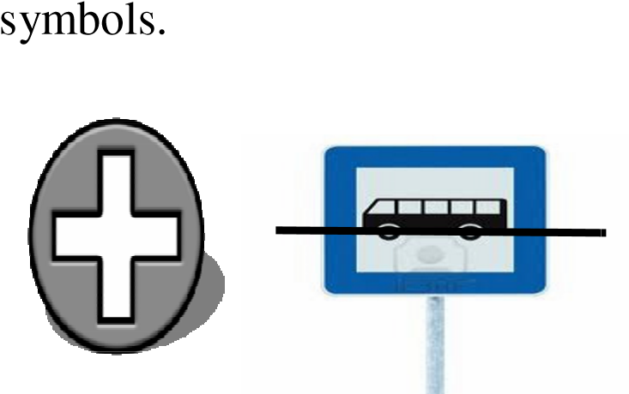

2. Observe and write the name of these dresses.

3

. Observe and name it.

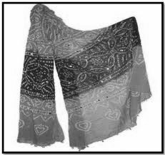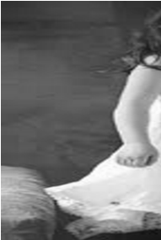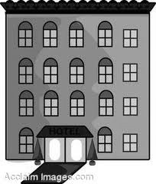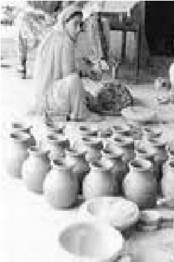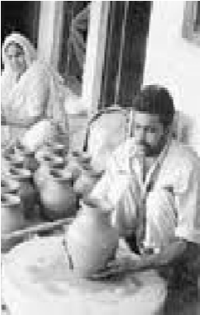

1. How many players are needed to play these games?

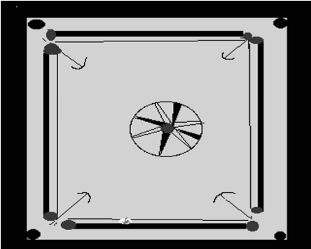

1. Give any two examples of temporary house.

(1) ------------------------(2) ----------------------------

(6)

Complete this food chain.

(7)

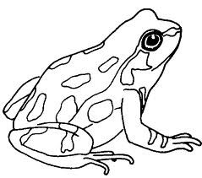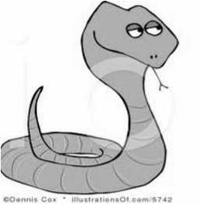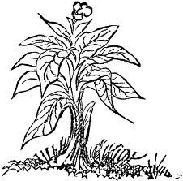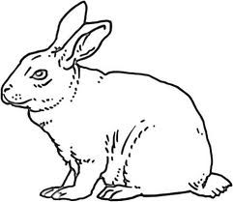

**II**.**Answer the following questions in short.**

(8) Write any four types of houses. 1) 2)

3) 4) 9)What kind of problems do people have in old age?

-------------------------------------------------------------------------------------------------------------

-------------------------------------------------------------------------------------------------------------

-------------------------------------------------------------------------------------------------------------

(10) Write any five natural things.

1) 2) 3)

4) 5)

(11) What are living things?

-------------------------------------------------------------------------------------------------------------

-------------------------------------------------------------------------------------------------------------------------------------------------------------------------------------------------------------------------

**III. Answer the following questions briefly:**

(12) Write the steps involved in making cotton cloth.

.

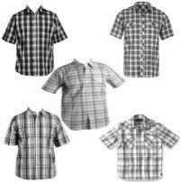

**IDENTIFICATION**

**IV. Read and draw.**

(13) Book behind the baby (14) Chair in front of the baby

(15)Tree on left side of baby (16) Animal on right side of baby.

(17

)

Name any two indoor gam



es

.

(1) (2) _______________________

**V. Answer the following questions in short.**

(18) Name the animals which can,

1. give us milk. 1. ______________ 2. ________________________
2. eat us. 1.___________________ 2._________________________

1. Write the difference between joint family and nuclear family.

|  |  |
| --- | --- |
| **Joint family** | **Nuclear family** |
|  |  |

1. How can we reuse the water? Give any two simple ways**.**

-------------------------------------------------------------------------------------------------------------

-------------------------------------------------------------------------------------------------------------------------------------------------------------------------------------------------------------------------

1. What is a map?

-------------------------------------------------------------------------------------------------------------------------------------------------------------------------------------------------------------------------

1. Write any four mathematical symbols you have learnt.

1) 2)

3)

4)

**VI. Answer the following questions briefly**

(23) Besides drinking, how is water used in your house? (Clue: Uses of water)



(1)

(2)

(3)

(4)

**DISCOVERING FACTS**

**VII. Fill in the blanks:**

1. Cotton cloth is good to wear in season.
2. The sun rises in the direction.
3. Tanka is a way of collecting.
4. is mostly used by the travellers and soldiers.
5. script is read by running the fingers on the raised dots.

**VIII. Answer the following questions in short**

1. Write your full home address in the Post card given below.

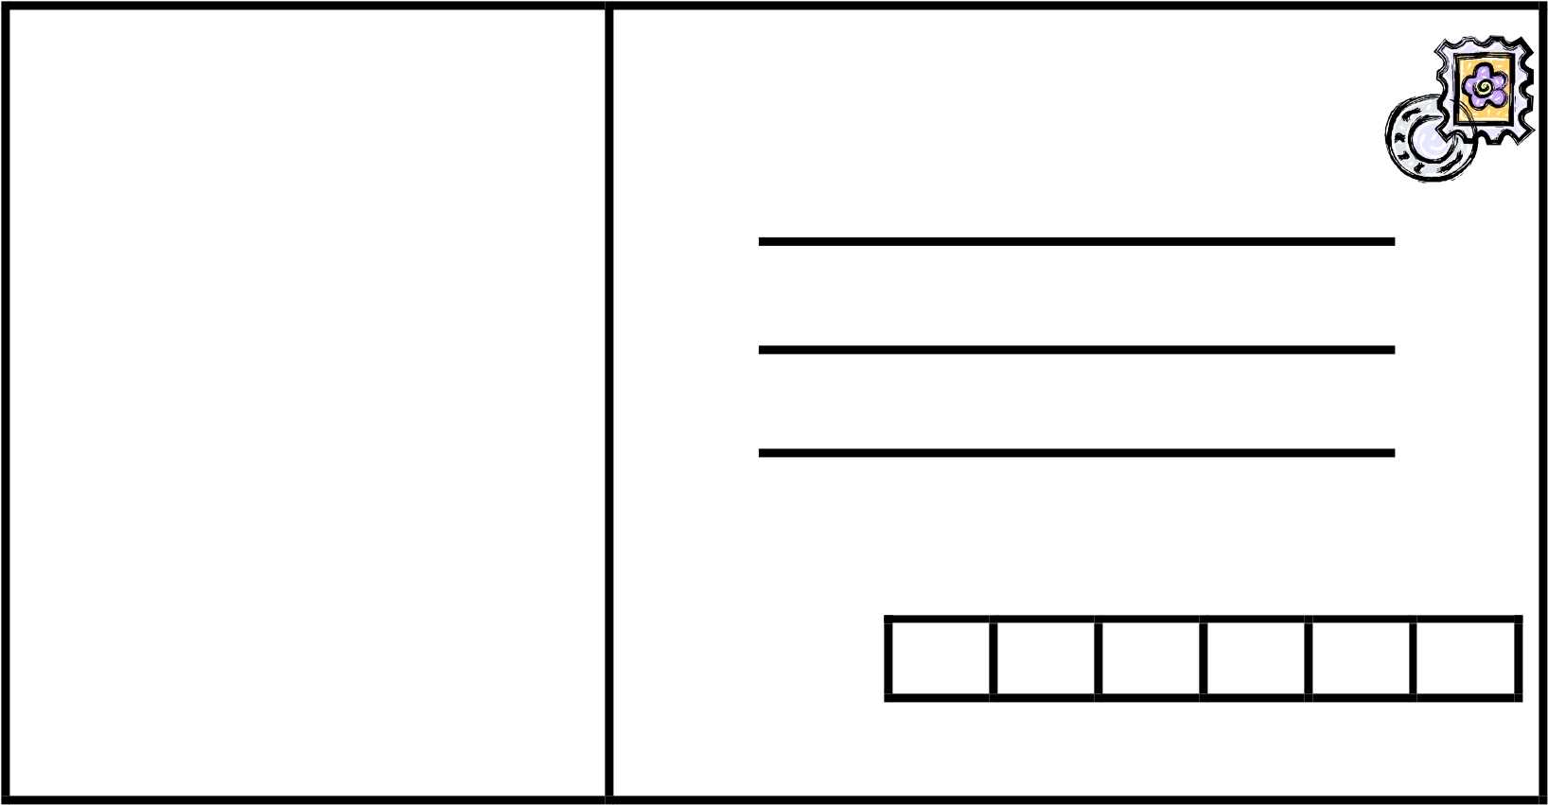

1. Write the difference between living things and non living things.

|  |  |
| --- | --- |
| **Living things** | **Non living things** |
|  |  |

1. Enlist the material used to make kaccha house.

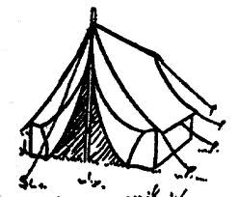

((1)

(2)

(3)

(4)

(32)

Draw your family tree.

(33) Write any four features of living things.

-------------------------------------------------------------------------------------------------------------

-------------------------------------------------------------------------------------------------------------------------------------------------------------------------------------------------------------------------

**------------------------------------------------------------------------------------------------------------**

**IX. Answer the following questions briefly**

(34) Draw any three types of house, name it and write a sentence about each.

1.

1.Name:

2

.Name:

3

.Name: